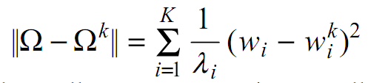

Báo cáo sử dụng *Mahalanobis*

Ảnh test



Ω = [-94.3679241 -1400.56234598 -2437.93176711 30.17753449

1799.71439004 9.22175401 -1189.82923552 1598.76775119]

λ = 52263811.59868378

λ = 44455162.12753218

λ = 40297542.10086153

λ = 25161799.88440414

λ = 21243458.763334613

λ = 11735475.05878545

λ = 9981365.471833248

λ = 6264214.710165009

ΩK =